Liquid limit

(upper plastic limit, Atterberg limit)

1.The water content corresponding to an arbitrary limit between the liquid and plastic states of consistence of a soil.
2.The water content at which a pat of soil, cut by a standard-sized groove, will flow together for a distance of 12 mm under the impact of 25 blows in a standard liquid-limit apparatus.

Soil Bulk Density

Compaction, Porosity and Soil Temperature

Soil Compaction

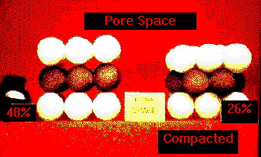
Soil compaction works something like the balls seen below. When the soil is randomly fluffed, as on the left, the amount of pore space will be 45 to 55%. When we push the soil particles closer together, we remove the pore space, and the bulk density will increase. Compaction increases the bulk density by reducing the pore space.

Compaction can also result in the changing of the proportion of pore sizes. Notice in the compaction diagram that compacted soils not only have a lower total pore space (resulting in higher bulk density), but also less macro pores and more micro pores. This will often result in excess water retention.

Compaction changes the amount and size of pores. See the Compaction Diagram.

C.O.L.E.

One of the important engineering properties of soils is related to the clay content and consistency and is called the coefficient of linear extensibility or C.O.L.E. It is a measure of the shrink-swell potential, or the volume change of the soil with changes in moisture content. If the C.O.L.E. exceeds .09, significant shrink-swell potential can be expected.

Soils with high C.O.L.E. values can cave in basements, displace walls, and break gas or water pipes. Knowing which soils have high C.O.L.E. values is an important step in selecting sites for construction activities. Compacting soils reduces the ability of soils to take on water and reduces their shrink/swell potential.

C.O.L.E. = (Length Moist÷Length Dry) -1

Porosity

Bulk Density is an indirect measure of soil pore space. In fact, there is a formula: 100 - ((B.D./Particle Density) X 100 ) = % pore space or POROSITY. Under field conditions, pore spaces are occupied at all times by air and water. "Tortuous pathways" best describes soil pores. Porosity, when expressed as a percent, is the same thing as percent pore space.

Soil particles have irregular shapes, and thus the spaces or pores between them vary irregularly in size, shape and direction. Sandy soils have large continuous pores, while clays have small pores that transmit water slowly. Clays, however, contain more pore space than sandy soils, because of the pores inside of the soil peds.

See the pore space and texture diagram.

To growing plants, pore sizes are of more importance than total pore space. We will be discussing this more in the unit on soil water.

Particle Density

In the laboratory you will determine porosity and particle density for the sandy soil used previously. Particle density will also be determined for this soil. Particle density only takes into account the volume occupied by the solid particles. It excludes the volume occupied by air and water.

Since a large portion of most soils is composed of particles derived from quartz minerals, the particle density of most soils is near 2.6 g/cc, which is the density of quartz. Variations in the particle density are due to the presence of heavier minerals like iron oxides or lighter organic components.

Significance of Porosity
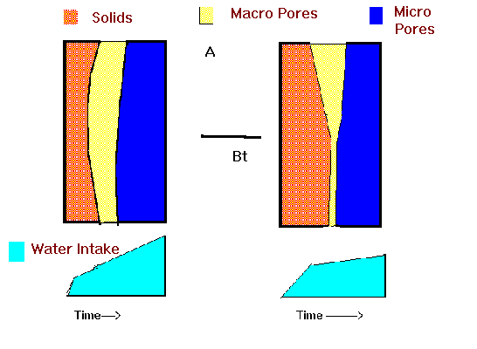
<Picture>

Above, a weakly developed soil is on the left and a well developed soil is on the right. Where clay accumulation is minimal, the macro pore space is about the same with increasing depth. However, where clay has moved into pores, the amount of macro pores and the rate of water movement both decrease. Soils with clay films will have slow water flow through the Bt horizon.

<Picture><Picture>

Some soils are difficult to aerate by plowing due to the turf cover. For lawns, playgrounds, or football fields, aeration is accomplished by making small holes in the turf with solid tines or using hollow tines to pull out a small core. Later the holes can filled with sand to promote air exchange. This is called aerifying and topdressing.

Many home lawns are compacted because of the construction activities when the home was built or due to people walking or riding on the turf when the soil is wet. Aerification will improve the turf growth on these lawns.

Soil Temperature Regimes

The temperature of a given soil at a given time is dependent upon the gains and losses of heat energy. Generally, dark surfaces will absorb more heat than light surfaces. However, the amount of water in the soil is an important factor. Losses of the absorbed heat are by radiation back into the atmosphere as long-wave radiation, heating the air and cooling the soil.

These soils warm quickly in the spring due to their dark surface.

Soil temperature regimes are used to classify soils. They are defined according to the average annual soil temperature in the root zone. The use of soils for agriculture and forestry is closely related to soil temperature, due to the specific requirements of plants.

Over most of the earth, daily soil temperatures below 50 cm deep seldom change. To approximate the mean annual soil temperature, 2'F is added to the mean annual air temperature. If we do this for the annual temperature map of Minnesota and follow the 45'F line, which would be 47' soil temperature, the state is divided along a line from the Twin Cities to the South Dakota border, and soils are frigid to the north and mesic to the south. See the map for this Mesic/Frigid line.

index properties

The principle indices used in geotechnical engineering include: plastic limit, liquid limit, shrinkage limit, and relative density.

Plastic limit is the lowest water content at which the soil exhibits plastic behavior.

Liquid limit is when the soil represents a near liquid state. This occurs at very high water contents when the soil behaves as a viscous liquid in that it flows and will not hold a specific shape.

Shrinkage limit is the water content at which there is no more volume change in the soil due to reduction in water.

Lecture 1 - what is soil ---ppt

Basic Soils Lecture
Lecture 1
Soil- the loose surface of the earth capable of supporting plant life.
Soils are Dynamic - the % air, water, organic matter vary with time and space.
Soil Dirt
Soil - Supporting Medium of Planet
Physical support of plants
Provides water and air
Provides essential elements
Macro-nutrients = N,P,K,Ca,Mg,S
Micro-nutrients = B,Fe,Mn,Cu,Zn,Mo,Co,Cl
Goals for studying Soils
Understand soil variability
Study physical, chemical & biological properties
Relate soil characteristics to various land uses
History of Soil Science
Cato - 150 BC - wrote practical handbook for Ag.
Van Helmont - 1600 -experiemented to understand relationships of soil-water-plants
Jethro Tull - 1700 - Cultivation essential and add nitre (nitrate salts)
Justice von Liebig - 1800 - german chemist - law of minimum - first list of essential elements
History (cont.)
Edmund Ruffin - 1850- Va. farmer - first to apply lime to soils for legumes
V.V. Dokuchaiev - 1900 - Russian - first to study soils and determine that they vary from place to place because of the factors associated with each place (soil forming factors)
Hilgard - 1900 - in Missouri - had the same ideas as Dokuchaiev

Roadcuts
The “Beautifull Soil Profile”

Soil Forming Factors

Parent Material ,Topography, Climate ,Vegetation ,Time,
Soils vary from place to place because the intensity of the factors is different at different locations.

Soil Parent Materials Residual - Soil formed from Bedrock. In Minnesota only the following: Sandstone Limestone Basalt Granite Transported Parent Materials Water - Rivers = Alluvium Wind - eolian = sand or silt (loess) Gravity = colluvium, Ice = Glacial Drift - all materials transported by ice or as a result of glacial activity Minnesota Glaciation Ice left Minnesota-Iowa border about 12,000 YBP (years before present) 40,000 YBP oldest glacial deposit in MN 10,000 YBP ice left MN-Canadian border Ice thickness = 1000 to 5000 ft. There were at least 4 advances of the ice and that complicates the history and the kinds of glacial parent materials.

Soil Forming Factor = Parent Materials from glaciation A. Unsorted Glacial Materials Glacial Till = unsorted deposits left by the retreating ice - can make up of sand, silt clay, gravel, boulders, stones and large rocks. Till can be deposited into various shapes Moraines- ground moraine - gently rolling plain End moraine - large hill or series of hills Drumlins - low hill shaped by the ice

Glacial Tills of Minnesota Superior Lobe Till - red in color, sandy, acid, rocks of granite, basalt, and sandstone Des Moines Lobe Till - gray or tan in color, loam to clay loam in texture, calcareous (free calcium carbonate present), rocks present- limestone and shale Sorted Parent Materials Water Outwash - often stratified sand or sand and gravel Lacustrine - lake deposited silt or clay texture (fine sediments- flat terrain, a former lake bottom Wind Loess - wind blown silt (.05 - .002mm diameter) Sand - dune sand - wind blown sand (eolian sand)

Soil Forming Factor - Climate Temperature - Warmer = Faster Cooler = Slower --> Soil Development Precipitation - higher rainfall = greater leaching Leaching Zone determined by CaCO3 Leaching Index = Pcpt. - Evapotranspiraton = the amount of effective rainfall that can cause soil leaching Leaching Index = 0 to 12 in Minnesota

Lecture notes - Soil Forming Factors 2 (ppt)

Soil Forming Factors - Biotic Animal - Soil Mixing~ earthworms, crawfish, scorpions, gophers ~ this mixing can result in the destruction of horizons.

Botic (cont.) Vegetation - Additon of Organic Matter (OM). Prairie ~ OM added to upper 2 ft. of soil due to fibrous root system of grass plants. Biotic (cont.) Forest ~ OM added to upper 4 " due to yearly leaf fall to surface of soil. Prairie - Border Bitoic Factor Prairie - Border soils have the influence of the prairie and forest ~ due to changes in vegetation over the past 8000 years the soils have been both under prairie and forest.

SFF - Topography or Landscape Position Catena - A series of soils that have different horizons due to different depths of the water table. Natural Soil Drainage Classes Well Drained - mottles begin > 4 ft. Moderately well drained - mottles > 3 ft. Somewhat poorly drained - mottles > 2 ft Poorly drained - dark surface - gray colors in subsoil below surface (red mottles) Drainage Classes
Topography - Erosion and Deposition Summit and Backslope Summit will have minimum erosion and maximum soil development (greatesthorizonation). Backslope will be similar to summit unless slope is > 20%. Shoulder Greatest erosion - least water infiltration - greatest runoff - minimal soil development. Footslope Deposition of materials from upslope - may be near water table - may have greatest leaching due to water from up slope and rainfall.
Aspect Direction the slope faces - important when slope is > than 10 %. Noticeable in SE MN. North Slope = 1. colder soils, 2. less evaporation , 3. more leaching ~ thus more soil development South Slope = 1. warmer soils, 2. more evaporation, 3. less leaching ~ thus less soil development. Hillslope in SE Minnesota Soil Forming Factor -

Time Vegetation and Climate act on the Parent Material and Topography over Time. The age of a soil is determined by its development and not the actual number of years it has been developing. How long it takes for a soil to become old depends on the intensity of the soil forming processes or the other 4 soil forming factors. Age Sequence Youth = Factors that retard soil profile development low rainfall high lime content high clay content steep slopes cold temperature severe erosion
What happens to a soil with time Loss of nutrients ( bases) = lower pH or soil becomes more acid increase in concentration of iron or soil becomes redder increase in clay content or old soils have more clay deeper weathering into the parent material Oldest soils in US are on high terraces and alluvial fans of the mountains in the western U.S. Oldest soils in United States

Lecture notes ON SOIL TAXONOMY USING POWER POINT SLIDES

For Slides of the Soil Orders see Soil Orders

Lecture 5 & 6

Soil Taxonomy- Diagnostic Surface Epipedons Mollic Epipedon - thick, dark, soft, surface layer. Characteristics: Thick - greater than 10 inches High base saturation Mineral soil Soils formed under prairie vegetation
Other Epipedons
Umbric - like mollic, but low base saturation
Histic - Organic Soil - saturated with water, > -% organic matter
Ochric - thin, light colored - surface layers that do not fit any of the above

Diagnostic Subsurface Horizons Argillic - illuvial horizon of clay accumulation - Bt Natric - same as argillic but with > 15% exchangeable sodium (Na) Spodic - illuvial accumulation of oxides of Al and Fe and OM, red or dark red color - only found in acid sandy soils, with high rainfall- generall found below E horizon. Contains a Bhs or Bs horizon subsurface horizons (cont.) Oxic - very weathered layer of only Fe and Al oxides and 1:1 clay minerals, low pH and not very fertile (found in tropical soils) Cambic - slightly altered layer - not weathered enough to be argillic, Bw horizon designation or development of color and or structure NONE - no diagnostic subsurfce horizon present

Lecture --Soil Texture - ppt

Soil Texture Soil texture is the single most important physical property of the soil. Knowing the soil texture alone will provide information about: 1) water flow potential, 2) water holding capacity, 3) fertility potential, 4) suitability for many urban uses.

Soil Texture Soil texture is determined by separating the amount of sand, silt and clay. Procedures:
1) Pipette method: soil is placed in 1000ml cylinder, pipette used to sample soil at selected depth to determine the % silt , % clay, and % sand is determined by subtraction.
2) Hydrometer: same as above but hydrometer used to measure amount of silt and clay, and later measure amount of clay, % sand determined by subtraction. Soil Texture Once the percent sand, silt and clay are determined the Textural Class Name can be determined using the textural triangle. Soil Texture Soil texture can also be determined by feeling the soil. This procedure takes practice but eventually a person can become very proficient and can estimate the % clay within 3% of the actual value.

Lecture Material for Soil Survey

Soil Survey --The soil survey is an inventory of the soil resource that involves three main elements:
1) a map showing the geographic relationships of each soil
2) a text describing the soils
3) tables giving physical and chemical data and interpretations for various uses.

Soil Survey-- A soil survey describes the characteristics of the soils in a given area, classifies the soils according to a standard system of classification, plots the boundaries of the soils on a map, makes predictions about the behavior of soils.

Soil Survey --The different uses of the soils and how the response of management affects them are considered. The information collected in a soil survey helps in the development of land-use plans and evaluates and predicts the effects of land use on the environment.

Map Scale--- Soil maps differ in their scale:
Map scale refers to how many inches on the map represents inches on the ground - a scale of 1:24,000 says 1 inch on map = 24,000 inches on the ground. or 1 inch = 2000 ft or 0.38 miles.

Making a Soil Map
1. Soil maps are not road maps - Soils boundaries are interpreted and the line is placed on the map by the soil scientist ; the lines on the map represent their interpretations of where the soil boundary changes.
2. Thus the only accurate soil map has a scale of 1:1 but that is not possible.
3. Soil maps are approximations of the soil boundary location - road maps have precise accuracy

Soil Mapping Units
Consociation - 75% named soil - 25 % inclusions
Complexes - 2 or 3 named soils = 75% 25 % inclusions on unamed soils

Order 1 soil survey - very detailed
Order 2 = regular soil survey
Order 3 = US Forest Survey
Order 4 = General Soil Map of a county
Order 5 = Soils of Minnesota Map

Lecture Urban Soil Problems (PPT)

Urban Soil Interpretations

Depth to Water Table Fertility Shrink / Swell Potential Bearing Capacity Erosion / runoff Topography Permeability

Depth to Water Table
Water in basement : need to provide drainage tile around the basement next to outer wall, water collected by sump pump in basement Fertility Fertile soils require fewer inputs for maintaining vegetation or establishing gardens. Unfertile soils will have less vegetation and more susceptibility to erosion.
Shrink / Swell Potential Soils with more clay have a high S.S. potential to avoid this problem soil must be compacted and water must be kept out. Without the above - Shrink/swell will crack foundations and pavements. Bearing Capacity ability of the soil to withstand a load soil stabilization - any method that prevents a soil system from moving under a load. Compaction - increase the density - thereby increasing stability - apply large pressure to soil at optimum moisture
Erosion & Runoff Concern during construction to prevent erosion Concern after construction - potential of upslope areas to contribute sediment to the house area Topography Concern about water and soil from upslope areas. Concern about depth to water table Concern about being on the floodplain
Slope - problem for erosion control and septic tanks drain fields Permeability = hydraulic conductivity of water through the soil Determines suitability for septic tank drain field. Sandy soils = rapid: Clay soils = slow; other textures = moderate Septic Tank System Septic tank drain field Percolation test : calculate perc rate by measuring time it takes water to drop 1 inch in a pre-wetted hole = time/drop in water level = min/inch Sewage flow = 450 gal/day 3 bedroom and 150 gal/day increase for each bedroom area in square feet of trench bottom per gallon of sewage flow per day. ie 6 in/min = 1.3sq.ft./gallon/day
Septic Systems The septic system consists of a series of four steps. 1. Septic Tank 2. Biological process occuring in the settling tank. 3. Dosing to the adsorbtion field. 4. The adsorbtion field.
Septic Systems If the complete septic system is working correctly the homeowner may never have to think where the waste is going. However, major failure of the system could cause major problems. Too slow percolation will cause the sewage to back up into the house. Too fast will allow insufficient time for microbes in soil to clean water Septic Systems They system can also fail if the biological organisms are no longer working to metabalize the waste. Detergents and bleaches in sufficient quantity can kill off the organisms. Thus, to avoid contamination of drinking water, they are placed away from wells. Septic Tank Mound System for Septic tank Drain field

Soil Weight Lecture Notes

Acre Furrow Slice = Area of one acre field x thickness of plowing = about 2,000,000 lbs.

Calculating Soil Weight

Acre Furrow Slice Calculation of inches of soil loss or tons of soil loss 1 g water = 1cc & 1 ft3 water = 62.4 lbs example soil BD = 1.2g/cc or 1.0/1.2 = 62.4/X? or X = 1.2x62.4 =74.9 lbs per cubic foot

Problem : For soil with BD of 1.2g/cc that lost 3 inches of soil per acre how many tons were lost?
BD=Wt/vol or 1.2x62.4 = Xlbs/43560ft2/acre x3/12
X = 74.9 lbs x 43560x3/12 = 8154432 lbs or 8154432lbs / 2000lbs/ton = 407 tons/acre

Determination of Linear Shrinkage
Purpose
See background. Specifically the shrinkage limit is the saturation limit of a cohesive soils and obviously provides an indication of how prone a clay is to liquifaction.

Apparatus
•Soil sample to be tested. •Oven to dry the sample. •Mould to put the soil in.

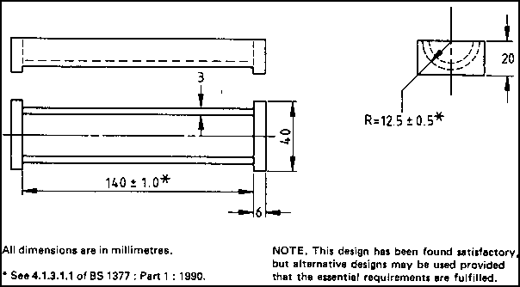
<Picture>

Procedure
•Clean the mould thoroughly and coat the inside with a thin film of silicone grease or petroleum jelly, this prevents the soil adhering to the mould and altering the results. •Take a sample of soil weighing approximately 150g from the material remaining after the Liquid Limit test, the soil will be a well mixed paste with a moisture content close to that of it's liquid Limit. •Place the soil paste in a mould so that it sits slightly high in the mould, gently jar the mould to ensure there are no air pockets present. •Level the soil in the mould with a pallette knife and remove all the soil adhering to the rim of the mould then measure the mean length of the soil in the mould. •Place the mould and sample in an oven at 105-110 degrees centigrade until the soil has finished drying. •Cool the mould and measure the new mean length of the soil sample, should a sample become curved carefully remove the soil from the mould and measure the top and bottom surfaces of the soil and take an average. •Note, should a specimen crack badly or break so much so that measurement is difficult repeat the procedure but use a slower drying rate.

Results
The Linear Shrinkage is measured as a percentage of the original length of the specimen.
The Linear Shrinkage of the soil is recorded to the nearest percentage

Typical Results

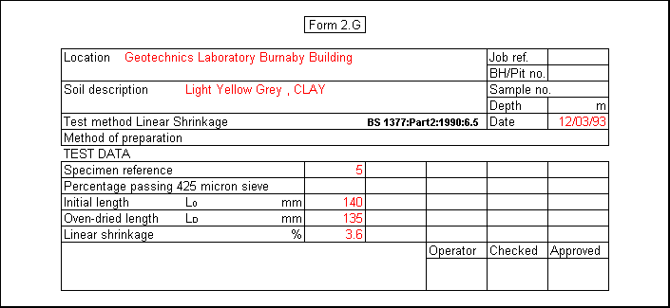
Conclusion

As can be seen from above the Linear shrinkage of the soil was 5mm this figure is meaningless except as a percentage of the initial length hence the Linear Shrinkage is 4%

Each of these soil classification tests has a British Standard form to aid correct calculation and external checking of results.

Enter your own data in a standard form from Quattro Pro.

There are mistakes made with each test that are made regularly by students every year

The Liquid Limit, Plastic Limit and the Shrinkage Limit are often called the limit or index tests the background behind these tests provides a useful insight into their development

